3.

(a) How many players have an unknown birthdate?

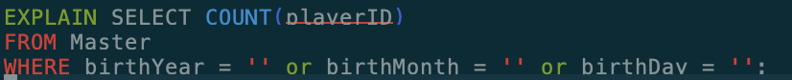



ADD Primary key:



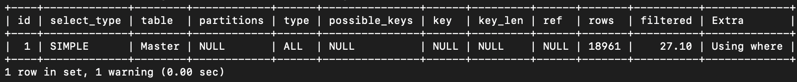

ADD INDEX:

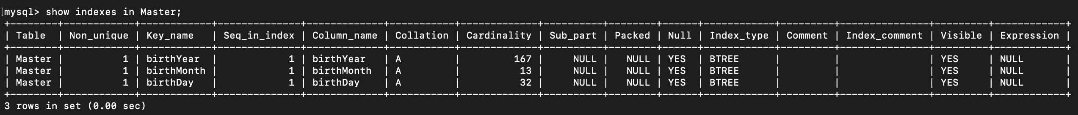



Thus, we can see the approximated number of rows to scan when adding index is much lower than that of only primary and without any indexes.

(b) How many people are in the Hall of Fame? What fraction of each category of person are in the Hall Of Fame? Are more people in the Hall Of Fame alive or dead? Does this vary by

category?

How many people are in the Hall of Fame?

Without primary key:

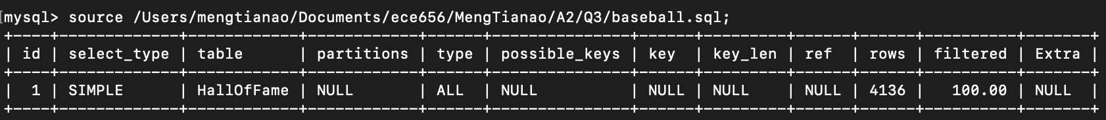

With primary key only:

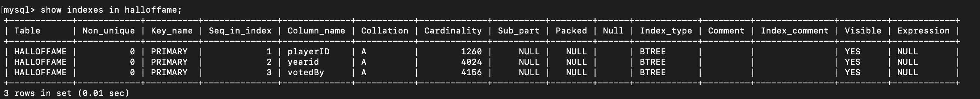



With Foreign key and primary key:

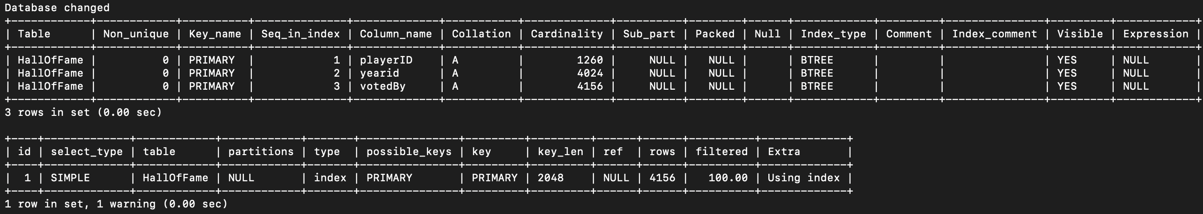

Add indexes:

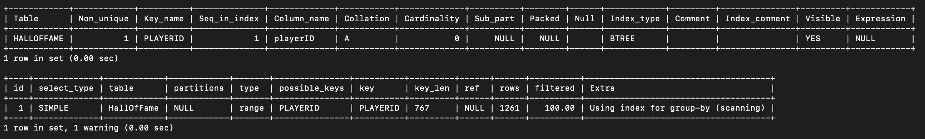

What fraction of each category of person are in the Hall Of Fame? Are more people in the Hall Of Fame alive or dead? Does this vary by

category?

Without primary key and foreign key:

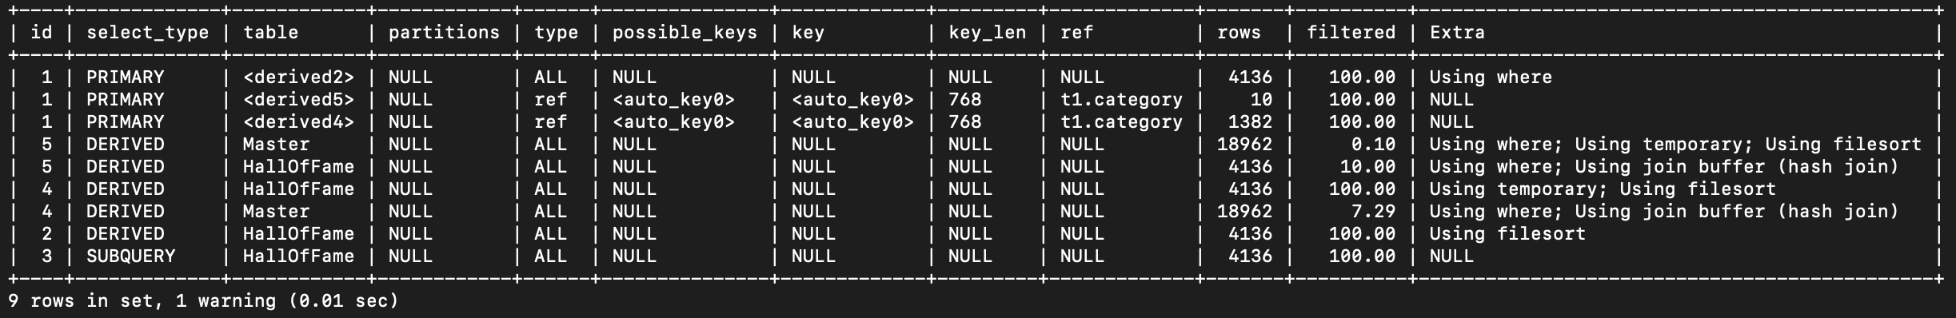

Only with primary key:

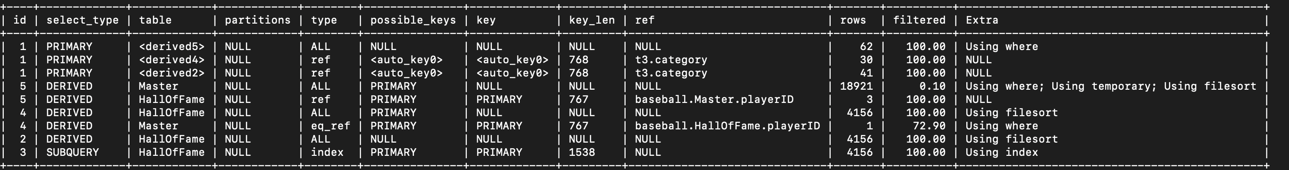

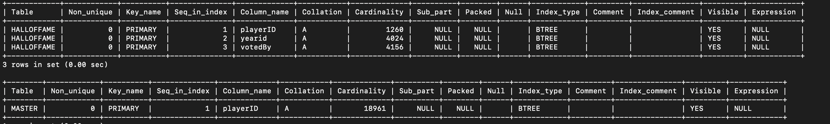

With primary key and foreign key:

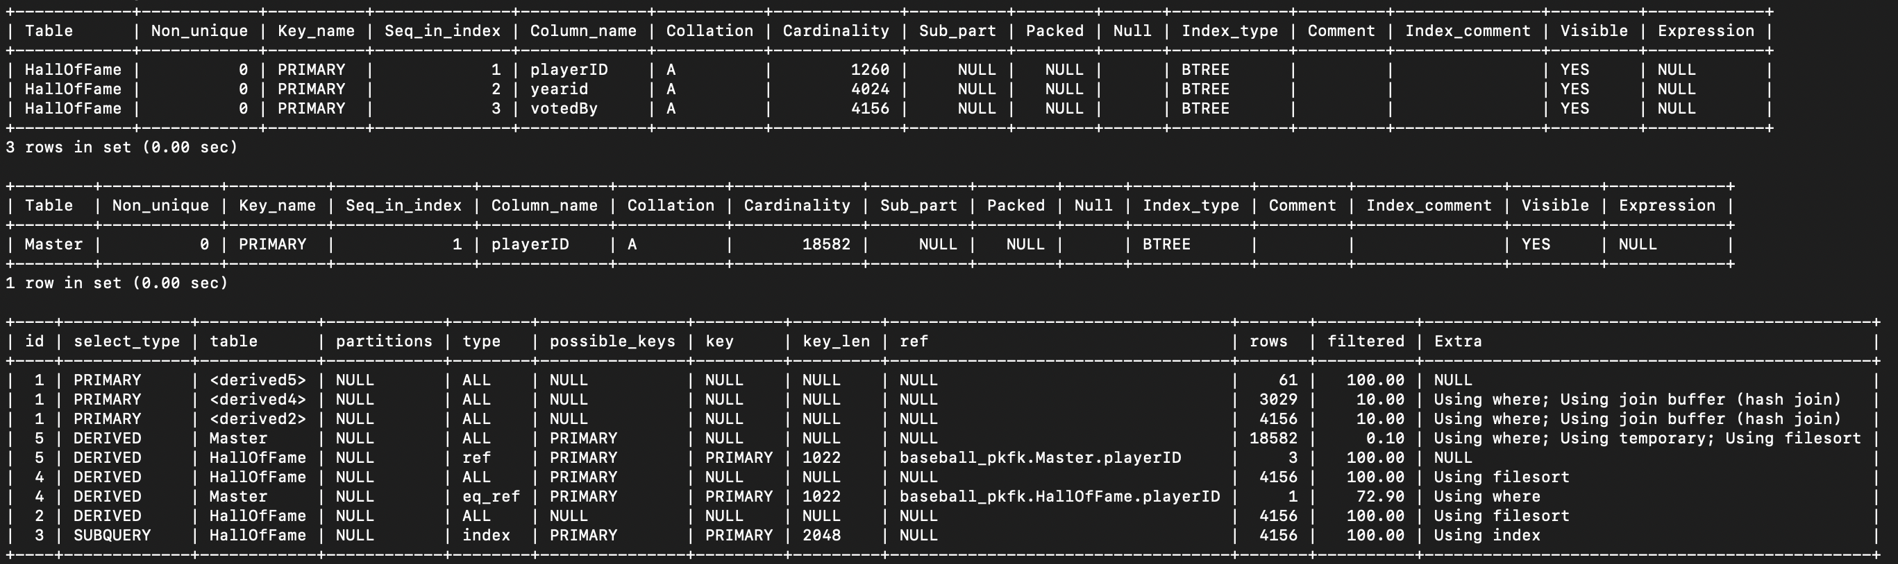

Add index on category:

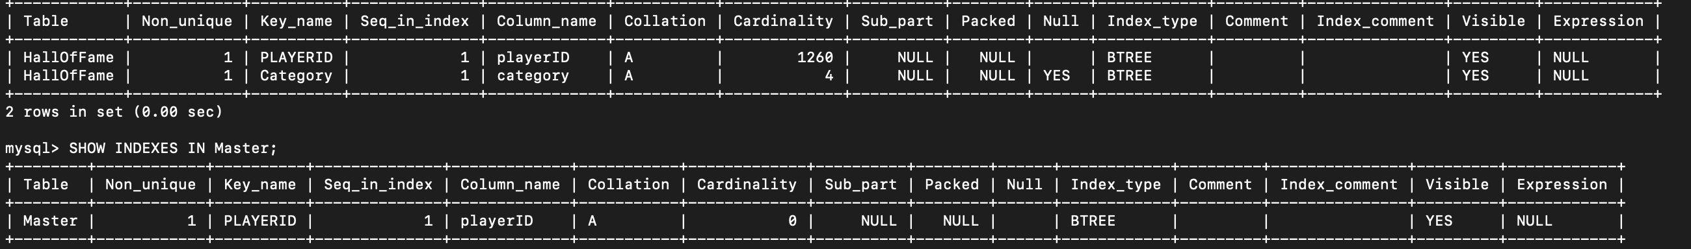

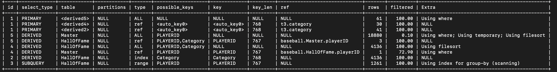

(c) What are the names and total pay (individually) of the three people with the three largest total salaries? What category are these people (Players? Managers? Other?)? What are the top three by category?

What are the names and total pay (individually) of the three people with the three largest total salaries?

Without any index:



With pk:

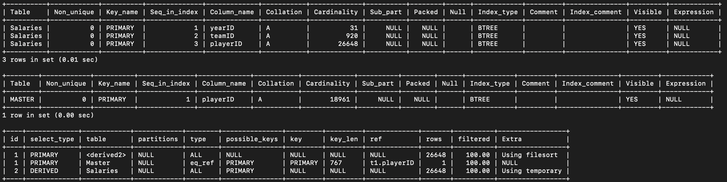

With pk and fk:

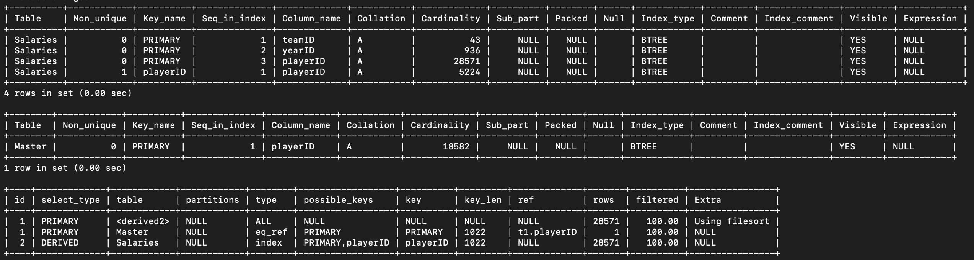

With index:

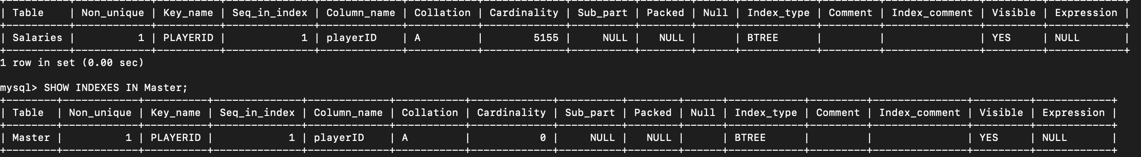



What category are these people (Players? Managers? Other?)? What are the top three by category?

Players Only:

Without any index:

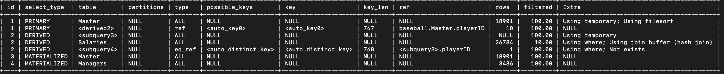

With pk:

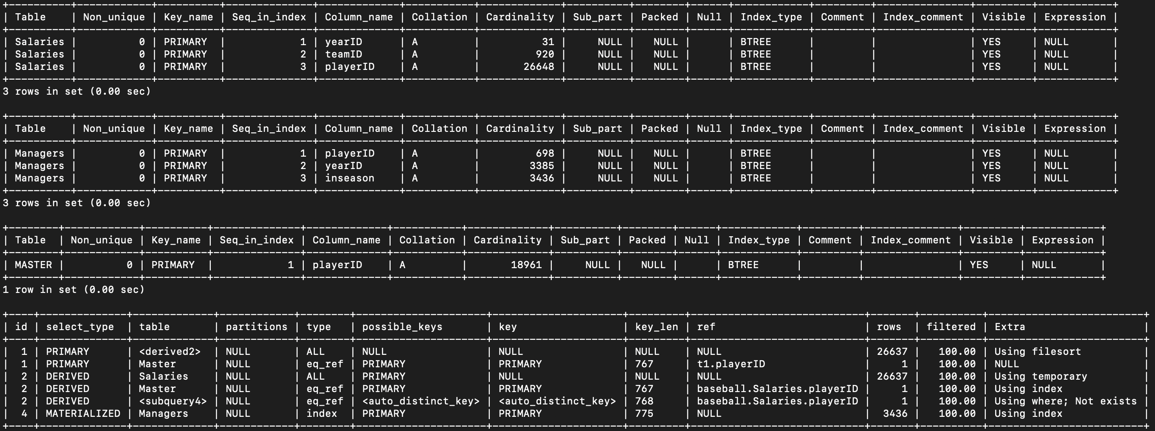

With pk and fk:

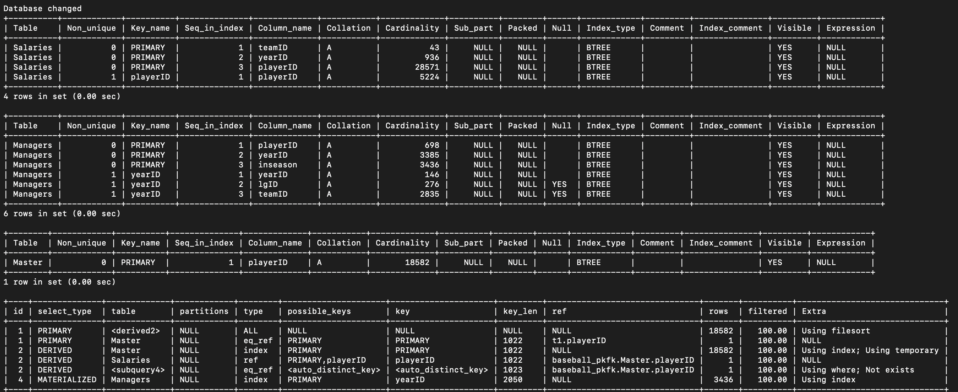

With index:

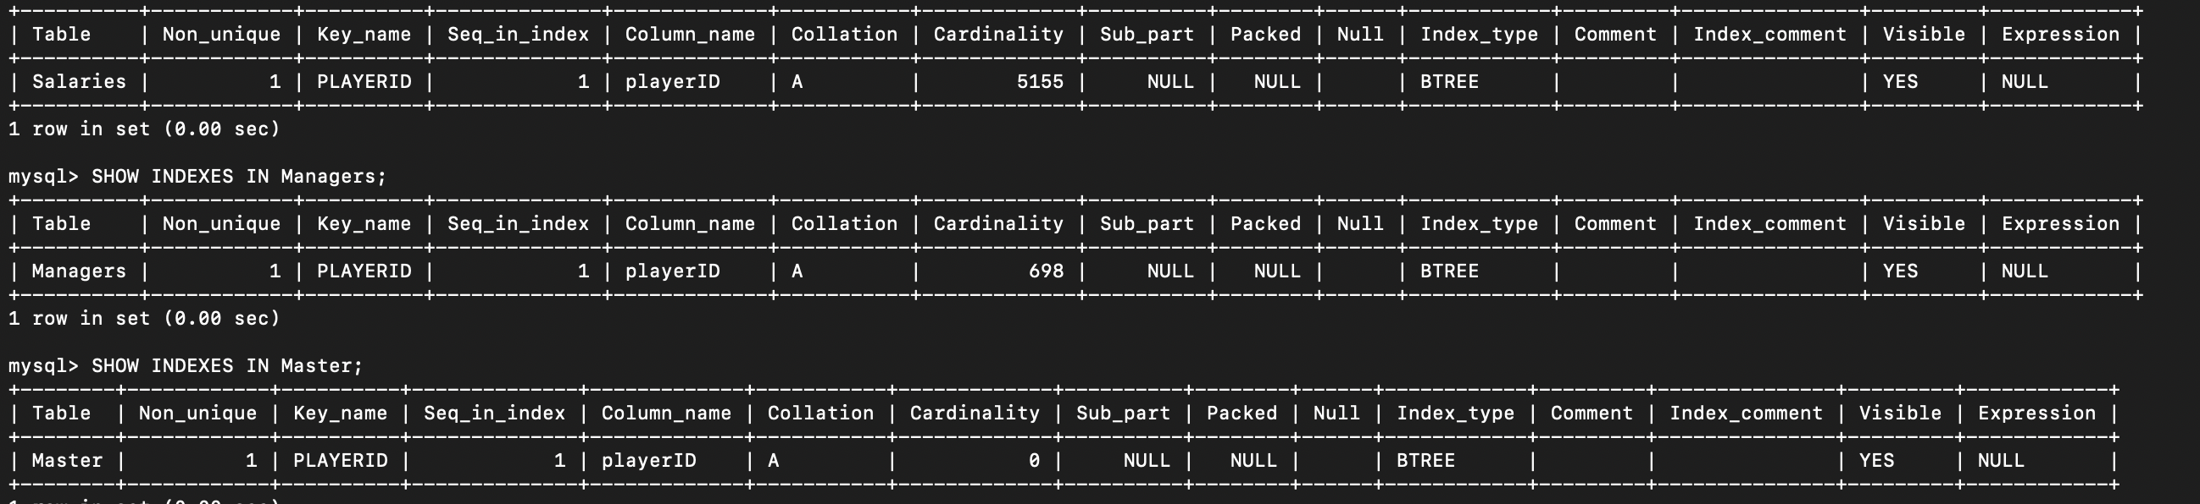



Managers Only:

Without any index:



With pk:

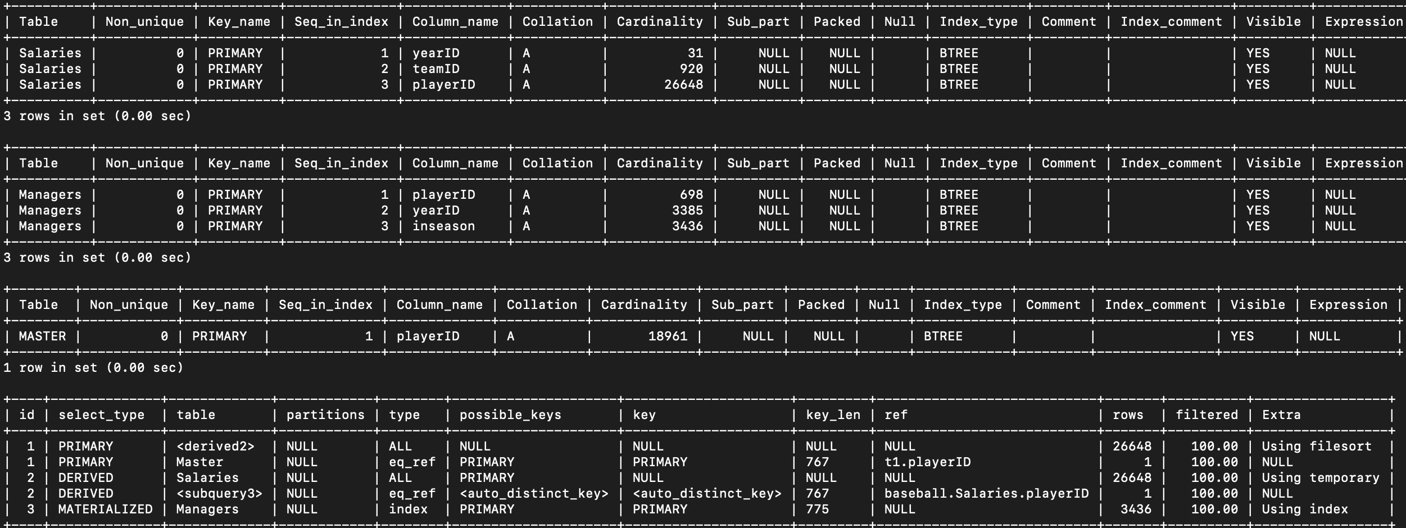

With pk and fk:

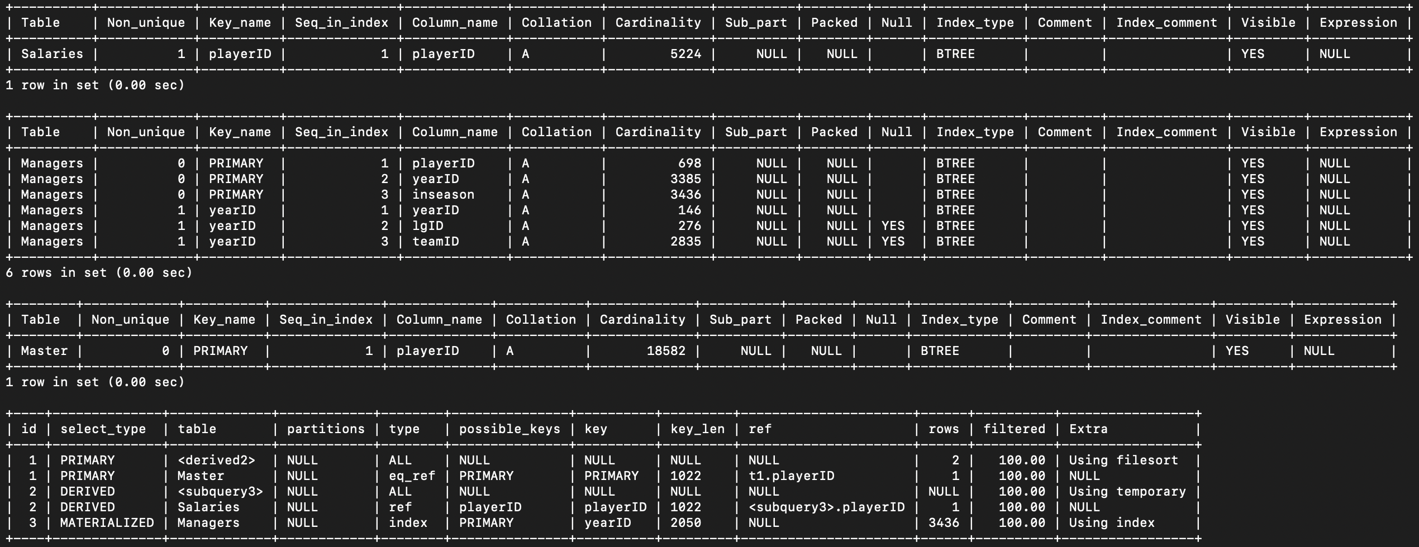

With index:

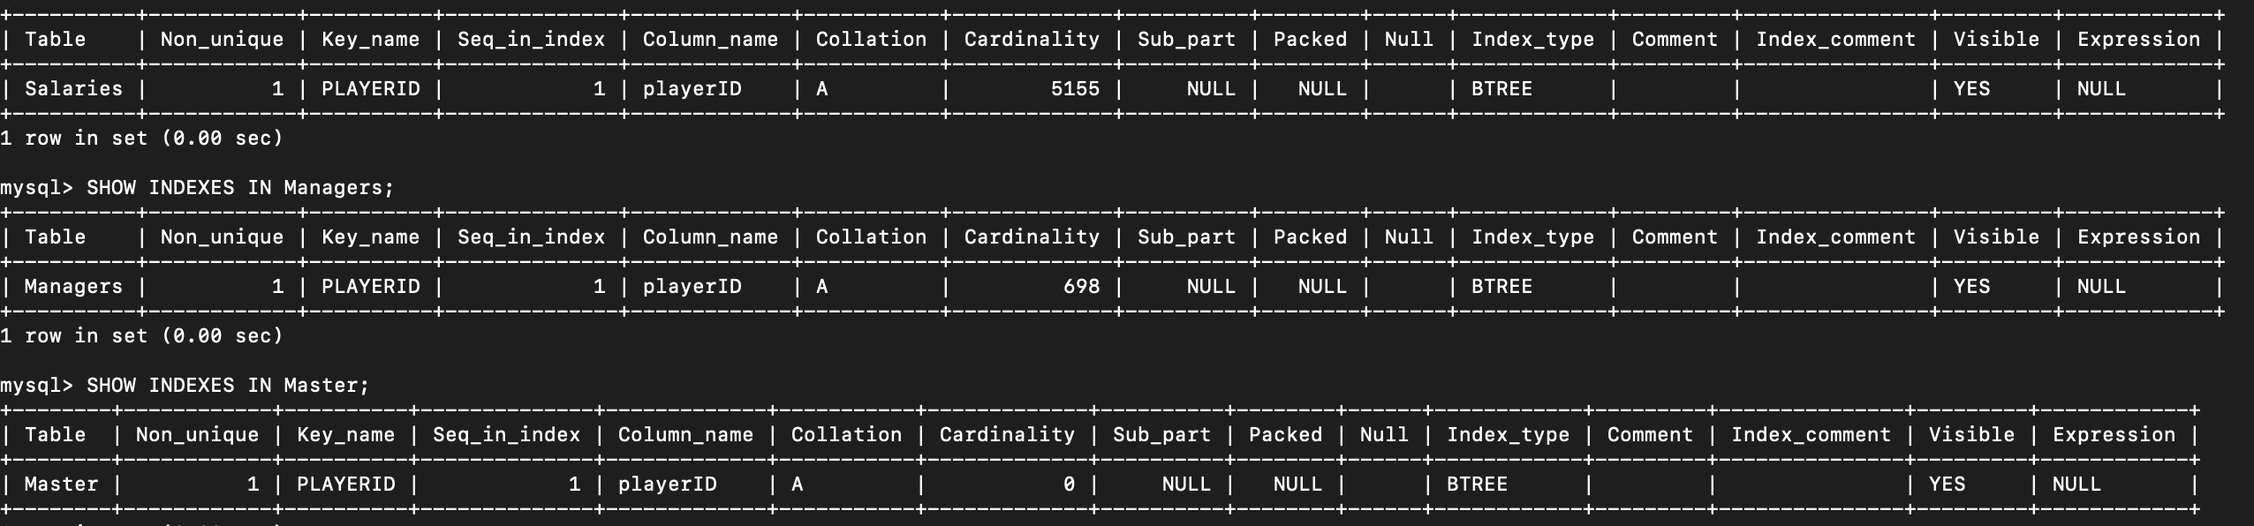



Other:

Without any index:

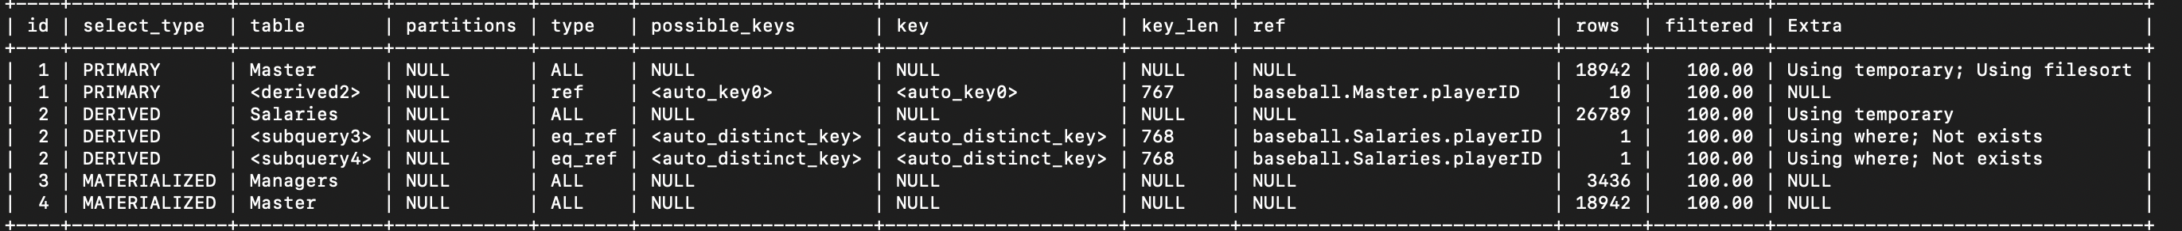

With pk:

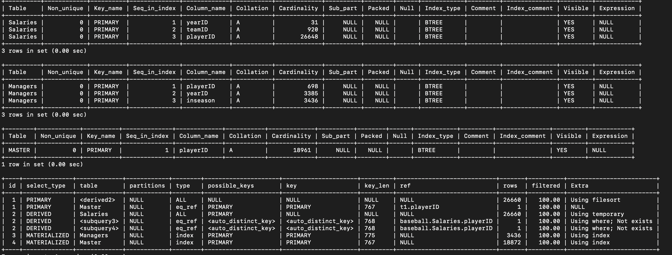

With pk and fk:

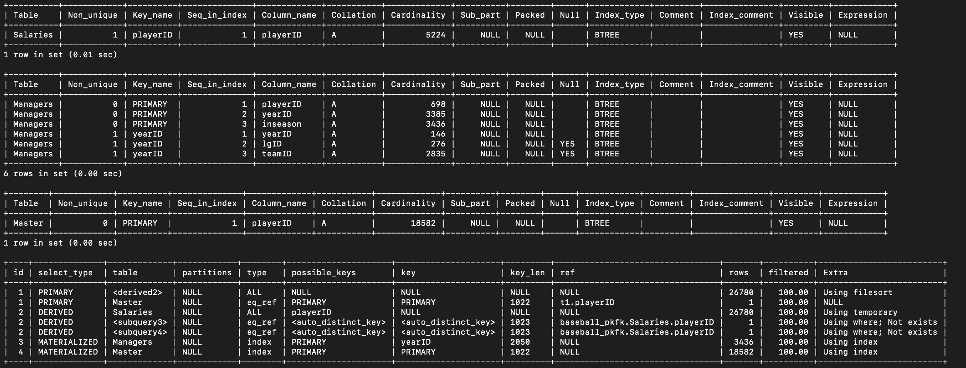

With index:

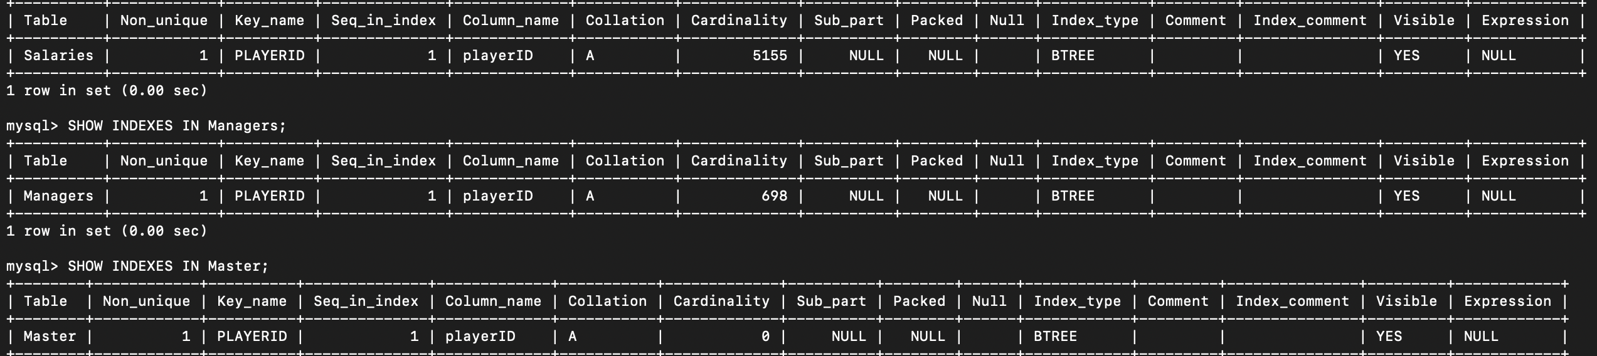

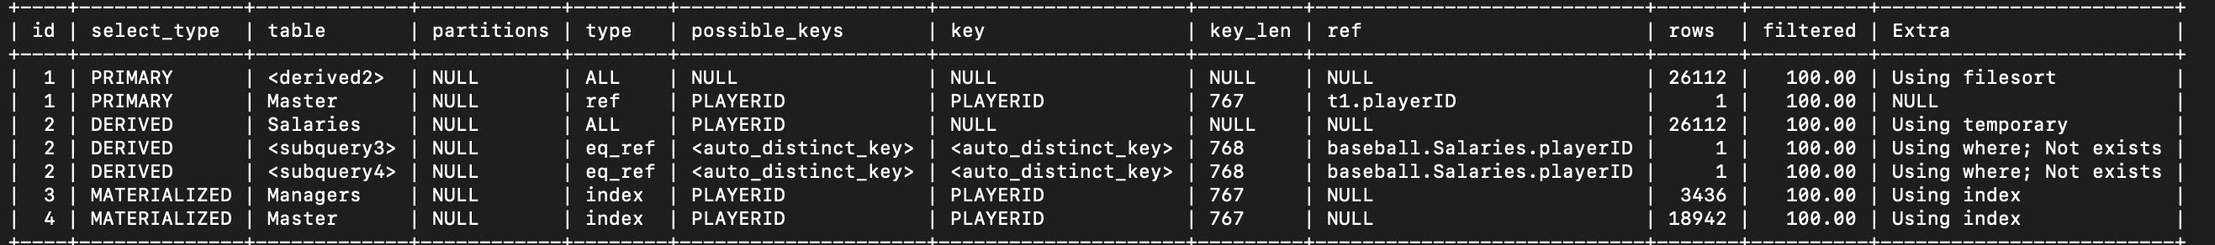

(d) What is the average number of Home Runs a player has?

Without any index:



With pk:

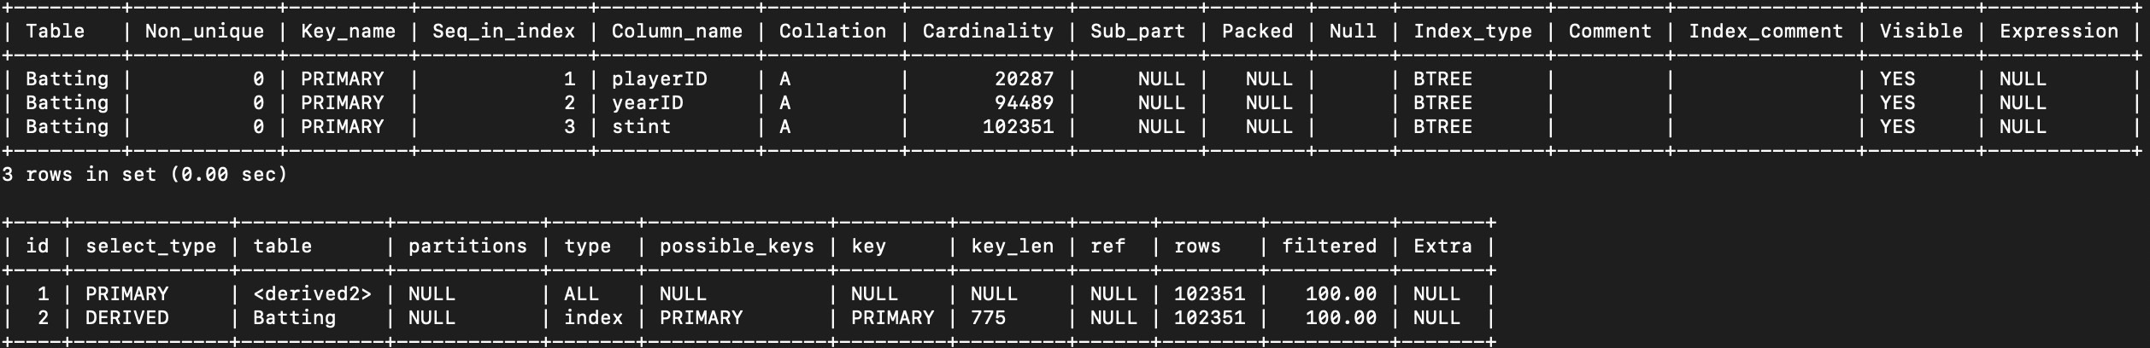

With pk and fk:

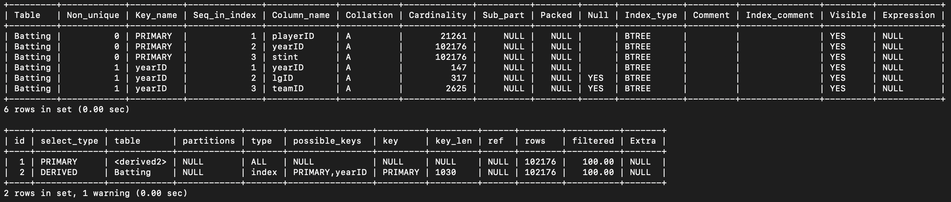

With index:

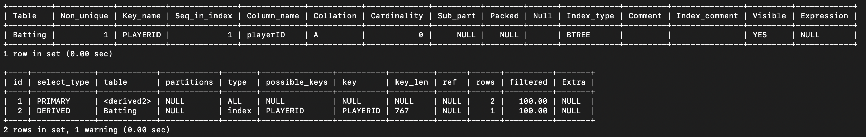

(e) If we only count players who got at least 1 Home Run, what is the average number of HomeRuns a player has?

Without any index:



With pk:

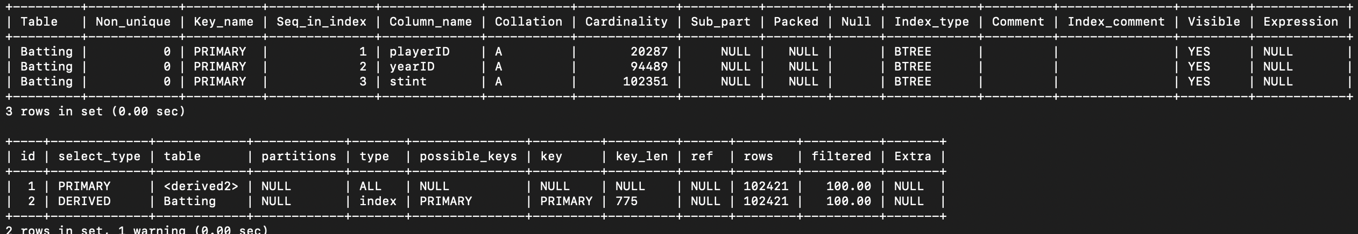

With pk and fk:

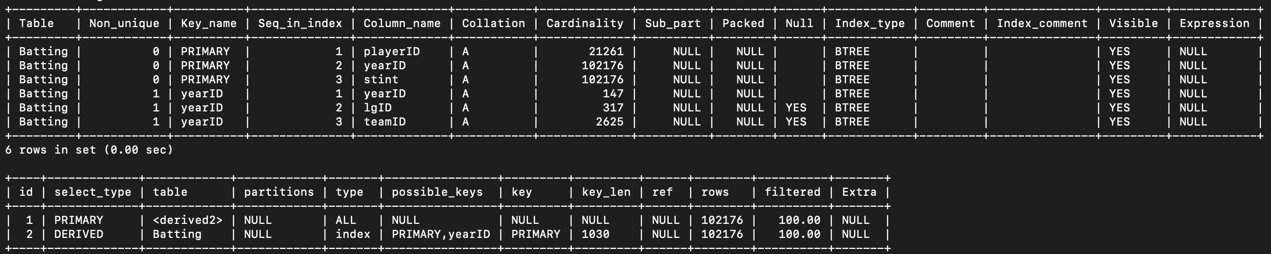

With index:





(f) If we define a player as a good batter if they have more than the average number of HomeRuns, and a player is a good Pitcher if they have more than the average number of ShutOut games, then how many players are both good batters and good pitchers?

Without any index:

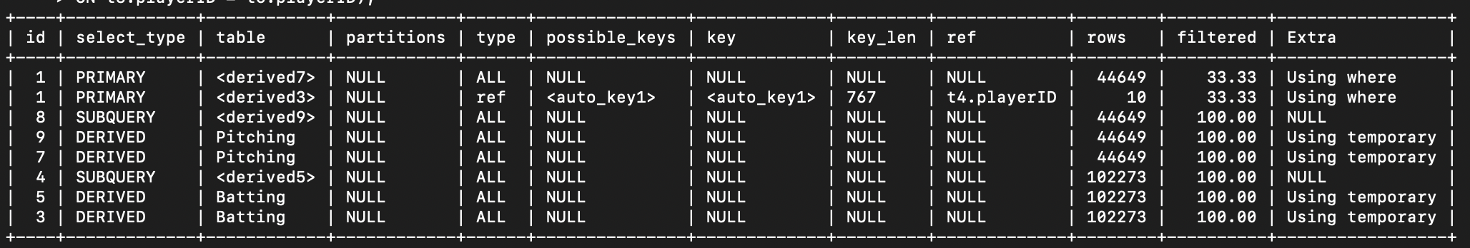

With pk:

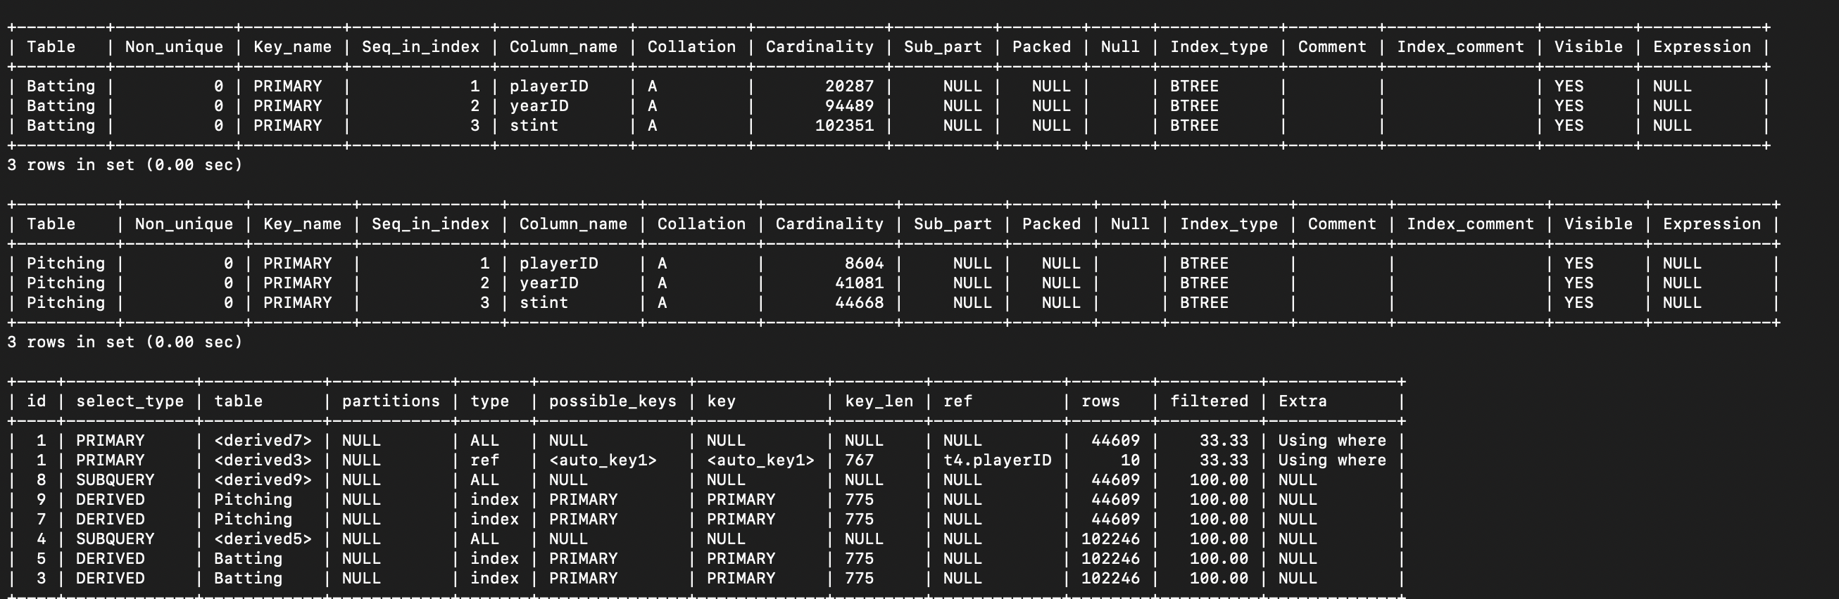

With pk and fk:

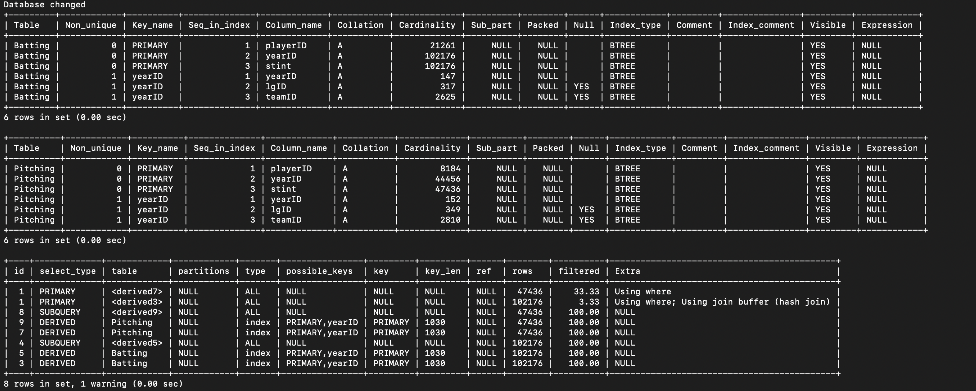

With index:

